

Assignment : 03

Submitted By:
Alina Mubarik 9067

TO: MA’AM SADAF

SUBJECT:MOBILE APPLICATION DEVELOPMENT(CS-375)

BATCH: SPRING-2024

01/12/2
DEPARTMENT OF COMPUTER SCIENCE

ABASYN UNIVERSITY
ISLAMABAD CAMPUS

TITLE: Mobile Application Development using React Native (Expo)

Introduction
This assignment focuses on developing multiple mobile applications using React Native with Expo. Each application demonstrates key concepts such as UI design, navigation, local database management, and state handling.

Tools & Technologies
- React Native (Expo)
- SQLite (expo-sqlite)
- AsyncStorage
- React Navigation
- React Native Chart Kit

Applications Developed

1. E-Commerce App
Description:
Displays products fetched from a local SQLite database.
Features:
- Product listing
- Product details screen
- Add to cart functionality
- Loading and error handling

2. Social Media App
Description:
A simple social feed application.
Features:
- Feed screen showing posts
- Post details screen
- Editable user profile
- Data stored in SQLite

3. Ticket Booking App
Description:
Allows users to browse movies and select seats.
Features:
- Movie listing
- Search functionality
- Seat selection system
- Save selected seats using AsyncStorage

4. Expense Tracker App
Description:
Tracks income and expenses.
Features:
- Dashboard with transactions
- Income, expense, and balance calculation
- Graphical reports using charts

5. Food Delivery App
Description:
Displays restaurants and order history.
Features:
- Restaurant listing
- Filter by cuisine
- Order history screen
- Navigation between screens

System Design
All applications follow:
- Component-based architecture
- Navigation using React Navigation
- Data storage using SQLite
- State management using React Hooks

Results
All applications were successfully implemented with functional UI and backend integration. Each app meets the requirements specified in the assignment.

Conclusion
This assignment provided hands-on experience in mobile app development using React Native. It enhanced understanding of UI design, navigation, local storage, and database integration.

Future Improvements
- Add authentication system
- Connect with real backend APIs
- Improve UI with animations
- Add cloud storage
SCREENSHOTS OF OUTPUT
E-COMMERCE APP:
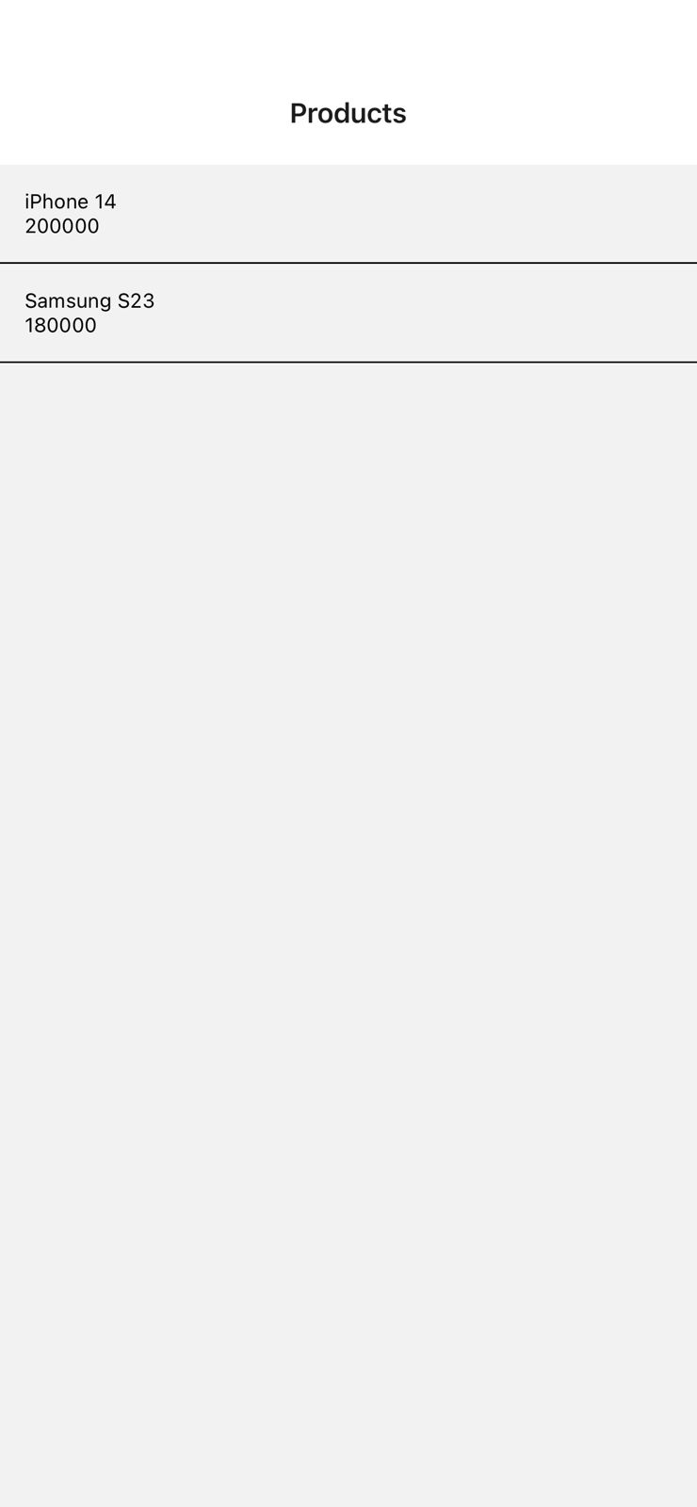

SOCIAL MEDIA APP:



TICKET BOOKING APP:




EXPENSE TRACKER APP:

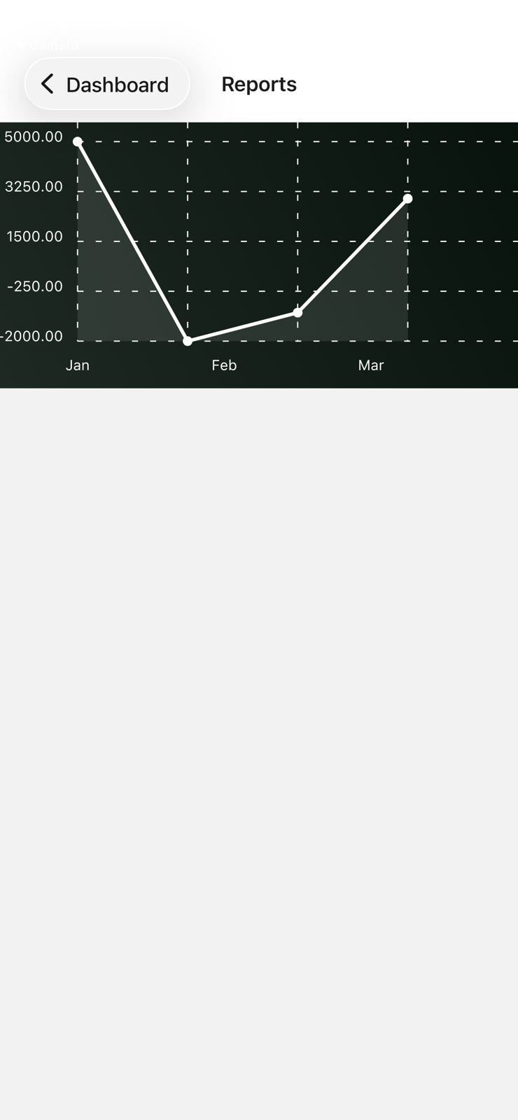
FOOD DELIVERY APP:
